*All financial contributions are tax-deductible.
Like us on Facebook: Lighting Longleaf
Contact us: lightinglongleaf@gmail.com
Dear Hattiesburg Community Supporter,

Lighting Longleaf is a community project focused on lighting the recently completed Longleaf Trace extension from the University of Southern Mississippi to downtown Hattiesburg. The extension has proven to be successful and runners, walkers, cyclists, school students and work commuters are already using it consistently. While this addition to the trace extension is certainly a success, there’s one glaring issue: it has no lighting! Lighting this section of the Longleaf Trace is of utmost importance as an investment in the health of the community and it helps ensure the safety of these runners, walkers, cyclists, school students and work commuters.

LIGHTING NEEDS:
We need over 90 lights to light 2 miles. To do that we need your help as a sponsor! The Longleaf Trace serves as one of our state’s most frequented tourist attractions and the lighting of the extension provides:

- Enhanced safety
- Means of recreation
- Increased commerce
- A way to connect midtown-to-downtown

BECOME A SPONSOR:
Lighting Longleaf is providing local businesses and community members the opportunity to financially support our community project by sponsoring individual lights installed along the recently completed Longleaf Trace extension. The benefits of sponsoring a light are two-fold: the Longleaf Trace can afford to install the light and the local business or community member can have their company name attached to that light (Sponsorship details are on the attached page 2). The light is guaranteed to be displayed for 10 years and will be seen by the thousands of visitors of the trace annually.

ABOUT OUR GROUP:
Our group consists of five (5) members from the ADP’s 2016 Leadership Pinebelt Class, a leadership training and education program which is comprised of a diverse network of leaders and community volunteers committed to shaping our community both economically and socially.

The growth, character, and culture of our community are enhanced by people like you who continually see its potential and choose to support its development! Please consider how you can support the lighting of the Longleaf Trace.

Your partners in service,
The Lighting Longleaf Team
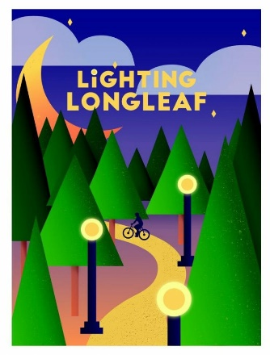
Sponsorship Opportunities
Light Pole Plaque - Lighting Longleaf 5K Glow Run & 1 Mile Walk
Thursday, September 15, 2016
Race begins at 7:30 pm
USM Longleaf Gateway

Benefiting Longleaf Trace 501(c)(3) – Lighting Longleaf Project

The newest extension of the Longleaf Trace has been completed and has runners, walkers, school and work commuters using its convenient track. While this addition to the trace has already proven to be successful we know that it is still limited by one, not so small factor, it has no lighting. We want people to be able to use the trace without being limited by time, or lighting. Safety, recreation, commerce, and midtown-to-downtown are enhanced by the construction of this newest trace addition but are currently also hindered from its full potential because of the lack of sufficient lighting. How can you help?

Platinum Sponsorship - $1,500
- Business name on (1) light post for 10 years  - Name & Logo in bold on back of t-shirt  - Name & Logo on Lighting Longleaf social media | - Name & Logo included in Thank You ad  - Three complimentary Glow Run entries  - Promotional items included in race bags
Gold Sponsorship - $750
- Name in bold on back of t-shirt  - Name & Logo on Lighting Longleaf social media  - Name & Logo included in Thank You ad | - Two complimentary Glow Run entries  - Promotional items included in race bags
Silver Sponsorship - $250.00
- Name on back of t-shirt  - Name & Logo on Lighting Longleaf social media  - Name & Logo included in Thank You ad | - One complimentary Glow Run entry  - Promotional items included in race bags
Bronze - $100
- Name included in Thank You ad | Friends & Family Sponsor - $___________________

Deadline to be displayed on the t-shirt is September 6th.

PLEASE COMPLETE THE FOLLOWING: [ ] $1,500 Platinum [ ] $750 Gold [ ] $250 Silver [ ] $100 Bronze [ ] $____ Friends & Family
Make checks payable to: The Longleaf Trace (write in memo: Lighting Longleaf)
Business Name: _______________________________ Email address_________________________________
Last Name: _________________________________ First Name: ____________________________________
Address: __________________________________________________________________________________
City: ___________________________ State: ________ Zip: ____________ Phone: ______________________

