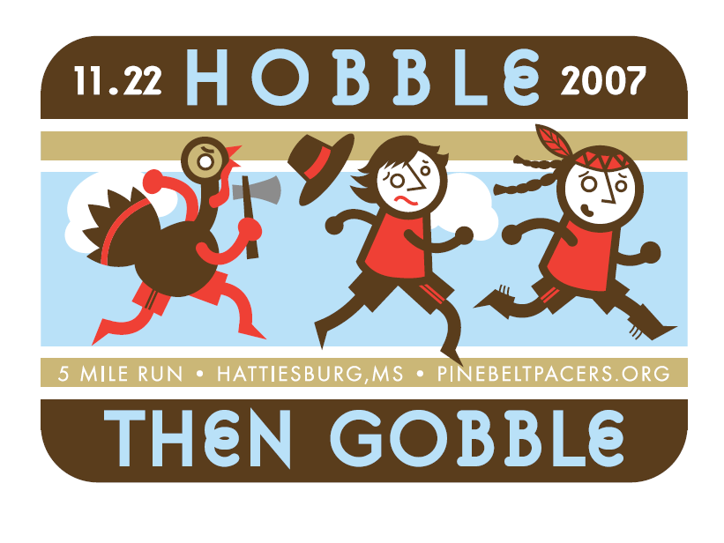

Benefiting children with Muscular Dystrophy &
Cross Country and Track Athletes at
The University of Southern Mississippi







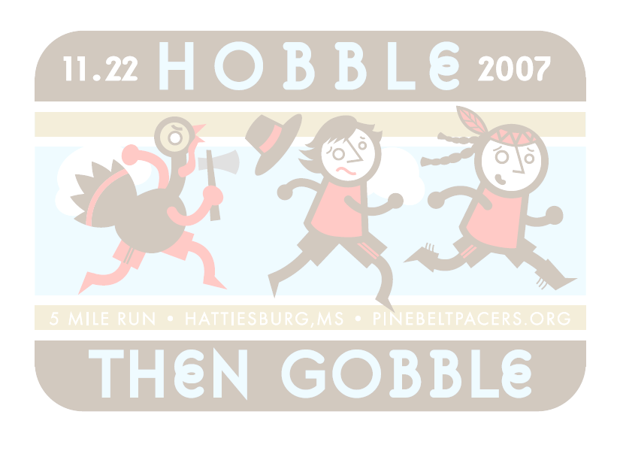
Thursday, November 22, 2007
Lake Serene Club House
(Hwy 98 West to West Lake Serene entrance)

Time:
5 mile run and walk begins at 8 a.m.
5 mile walk begins at 7:30 a.m.
1 mile fun run begins at 9 a.m.
Course: A scenic course between the lakes.
Awards:
- Turkeys will be presented to the overall, master & grand master finishers in both male and female categories.
- Trophies will be awarded to top 3 males and females in 10 year age groups for the 5 mile run
0 – 19, 20 – 29, 30 – 39, 40 – 49, 50 – 59, 60 – up
- Awards will be presented to the top three male and female walkers.
- T-Shirts:
T-shirts are only guaranteed on race day to those registered before November 17, 2007.
Post-Event Activities:
Refreshments and awards immediately following race.
Entry Fees:
- Pre-registration postmarked by November 17, 2007:
$18.00 all event categories
$15.00 PBP Club Members in pre-registration
- Day of Race registration:
$20.00 all event categories (ex., Fun Run free)
$10.00 no T-shirt option
$45.00 Families of 3 or more

- Additional information and on-line registration available on club web site: www.pinebeltpacers.org
- Registration:
- Mail completed registration before November 17, 2007 to address below; or
- Race day registration at Lake Serene Club House beginning at 7:00 a. m.
Hobble then Gobble 5 Mile Run & Walk
Benefiting children with Muscular Dystrophy & Cross Country and Track Athletes at
The University of Southern Mississippi
Registration
Name: ___________________________________ Age on Race Day:_____ DOB:___/___/___

Address: __________________________________ Phone: (home) _____________________

City / State / Zip: _______________________________ (day time) ____________________

Sex (circle one) Male Female T-shirt size (circle one) S M L XL

Event (check one): ___ 5M Run ___ 5M Walk E-mail address:____________________________

 Check to receive emails about other upcoming events.
Signature: ________________________________________ Date: ______/______/______
(Parent if under 18 years of age)

Make checks payable to: Pine Belt Pacers
Mail Entries to: Pine Belt Pacers, Attn: Dawn Smith, 353 Emerson Dr., Hattiesburg, MS 39401
Waiver for the Hobble then Gobble 5 mile Run and Walk

In consideration of the acceptance of this entry, I assume full and complete responsibility for any injury or accident which may occur while I am traveling to or from the event, during the event, or while I am on the premises of the event. I am also aware of and assume all risks associated with participating in this event, including but not limited to falls, contact with other participants, effect of weather, traffic, and conditions of the road. I, for myself and heirs and executors, hereby waive, release and forever discharge the event organizers, sponsors, promoters, and each of their agents, representatives, successors and assigns, and all other persons associated with the event, for all my liabilities, claims, actions, or damages that I may have against them arising out of or in any way connected with my participation in this event. I understand that this waiver includes any claims, whether caused by negligence, the action on inaction of any of the above parties, or otherwise.
I understand that the entry fee is non-refundable and non-transferable. I hereby grant full permission to any and all of the above parties to use any photographs, videotapes, motion pictures, web site images, recordings or any other record of this event.

